1. Abdulla Hamad Ahmed Bin Sugat Al Falasi | 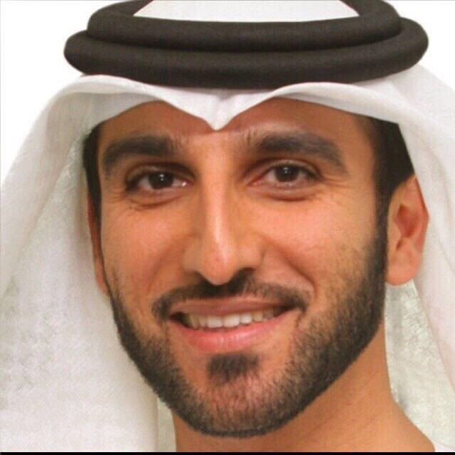
2. Abdullah Jassim Nasser Mohamed Alnowais | 
3. Ahmed Ali Mohammed Abdulaziz Alsarkal | 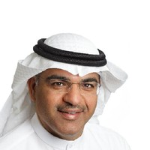
4. Ahmed Bin Eisa Bin Nasser Alserkal | 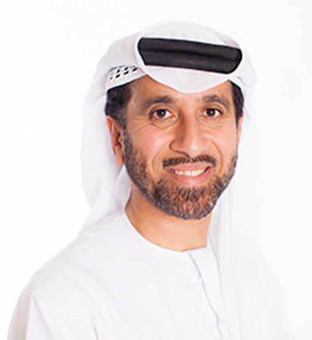
5. Ahmed Mohammed Hussein Hamdan Budebes
6. Dr. Ahmed Hassan Mohammad Bin Alshaikh | 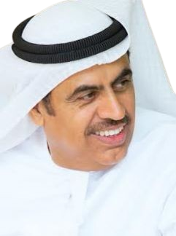
7. Dr. Faisal Ali Mousa Alnaqbi | 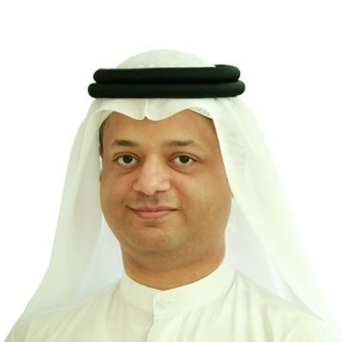
8. Dr. Mohammed Salem Obaid Aldhaheri | 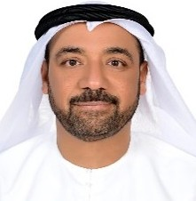
9. H.E. Dr. Mohammed Saeed Ali Khalfan Al Kindi
10. H.E. Sultan Mohd Ali Alqurtasi Almuaimi
11. Hamda Khalil Ibrahim Almansoori | 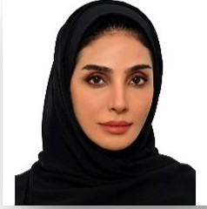
12. Jassim Mohammed Abduljalil Albastaki | 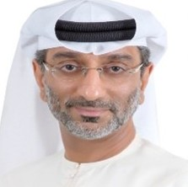
13. Mohamed Sultan Mohammed Alqadi | 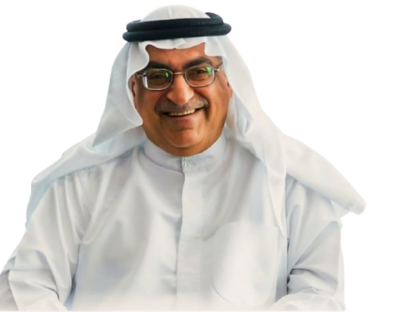
14. Mohammed Abdulla Ahmed Abdool Alkhumairi | 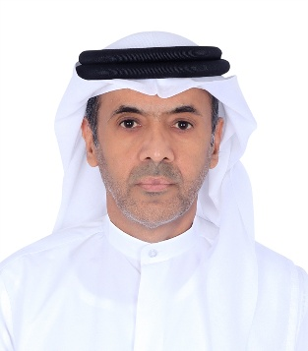
15. Mohammed Abdullah Mohamed Khalfan Bukhatir | 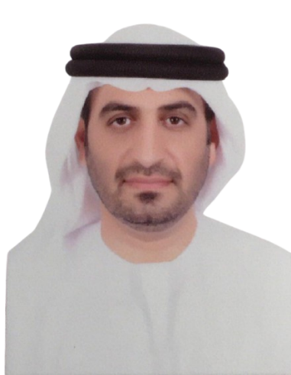
16. Mohammed Ali Abdulla Abdulrahman Al Ali
17. Mohammed Yousif Ali Fadhel Binfadhil Aghfeli | 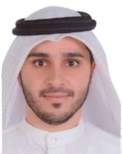
18. Roudha Yaqoob Alshamsi
19. Saeed Hamad Ibrahim Alhameli Alshams | 